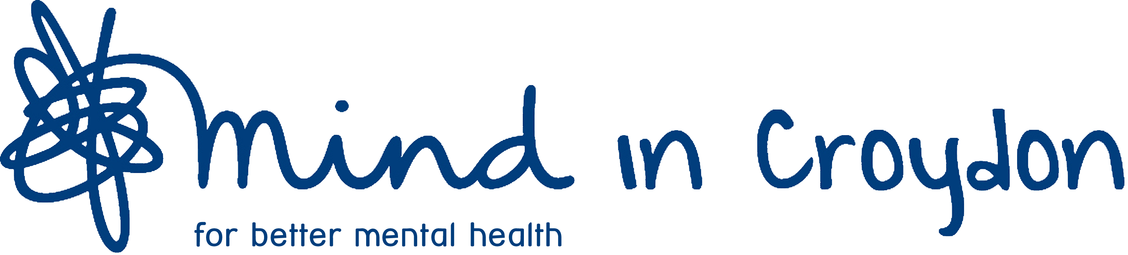

MIND IN CROYDON

PERSON SPECIFICATION

IMHA ADVOCACY WORKER

Listed below are the qualities or factors required of candidates for the post of IMHA Advocacy Worker. Listed below are the qualities or factors required of candidates for the post of Advocacy Worker. ‘E’ denotes essential criteria, while ‘D’ denotes desirable qualities or factors.

1. KNOWLEDGE AND EXPERIENCE

At least 1 years’ experience:

1.1 of working with people with a mental health problem E

  - of hospital and community mental health services E

1.3 of Health Service, Social Services and voluntary sector structures D

1.4 of Equal Opportunities issues E

1.5 of operating in a multi-racial setting D

1.6 of working as a mental health advocate E

1.7 of relevant mental health and community care legislation E
1.8 Of NHS and Social Services complaints procedures D

2. EDUCATION

2.1 Applicants must have completed and gained the full qualification, the Level 3 Certificate in Independent Advocacy (4 core modules) and the additional specialist module of Independent Mental Health Advocacy (IMHA). Details of the qualification can be found here https://www.blackbeltadvocacy.com/certificate-in-advocacy. The reason for this is that our service holds the Advocacy Quality Performance Mark (QPM) from the National Development Team for Inclusion (NDTi) and one of the requirements is that all Advocates within our service have to hold the qualification for our service to remain compliant with the QPM. E

2.2 Applicants must have a high level of literacy. E

3. SKILLS AND ABILITIES

3.1 in communicating effectively with people in distress E

3.2 in communicating and negotiating effectively with professionals
both in writing and at multi-disciplinary meetings E
3.3 in communicating effectively across cultural boundaries D

3.4 in working under pressure and coping with stress E

3.5 in acquiring relevant knowledge E

3.6 in effective time management E

3.7 in working co-operatively as part of a small team E
3.8 in maintaining the requirements of a confidentiality policy E

3.9 in working independently and taking initiative E

  - in using computers i.e. word processing, databases and spread sheets D

  - in developing links with community service user groups in different settings D

  - in speaking and writing fluent English and explaining complex information face
to face, over the ‘phone and in writing E

  - in writing clear and concise case records. E

4. PHYSICAL REQUIREMENTS

  - Sufficiently healthy and physically able to carry out the duties in the job description. We are always happy to make adaptations where reasonable. E

The present Advocacy office is on the first floor of a building where unfortunately there is no lift. There is a disabled toilet on the ground floor but not on upper or lower floors. Much of the work will also need to be done in other settings (mostly hospital sites).
  - Sufficient mobility to travel to other parts of the Borough and beyond is
required. E
(NB: Use of a car is desirable but not essential).

4.3 An ability to operate in a Covid secure facility for example, inpatient units where the use of PPE is mandatory. E

December 2020 (Final)

