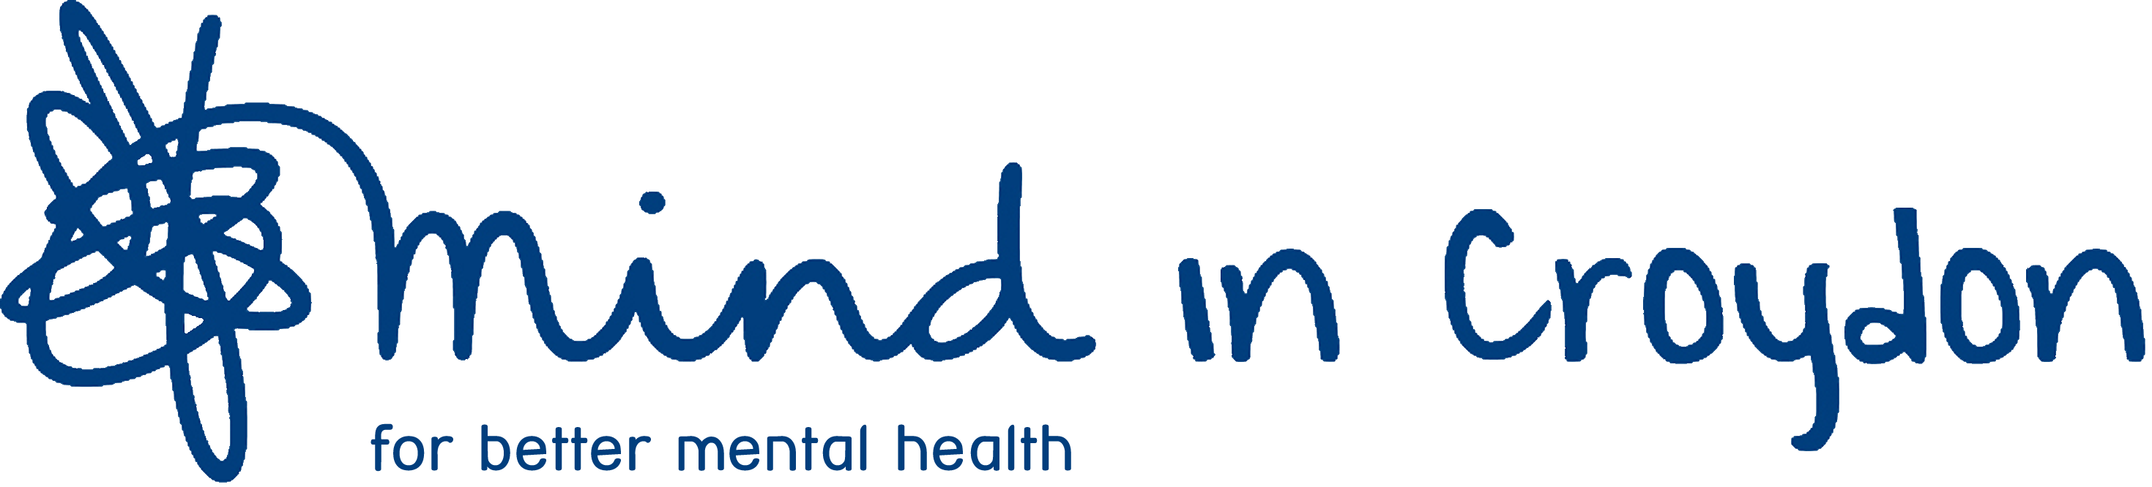

MIND IN CROYDON

IMHA ADVOCACY WORKER

TERMS OF EMPLOYMENT

Salary: £27,816 (Mind Grade 4 scale point S7) per annum.

Hours: 36 hours per week, full time

Holidays: 28 working days per annum plus public holidays. The holiday year begins on l April and employees joining after l April will be granted leave pro rata in their first year. When employees have worked for Mind in Croydon for a continuous period of at least 5 years, they are entitled to additional leave of five days to bring leave entitlement up to a maximum of 33 days per annum.

Pension: An auto enrolment compliant pension scheme run by NOW pensions is in place.

Notice: One month's notice on either side.

Probation: There is a probationary period of 6 months, which when appropriate may be extended. During the probationary period the required notice is one week on either side.

Detailed Terms of Employment applicable to all Mind in Croydon employees are available on request, and will be supplied to the successful candidate.

December 2020 (Final)

