Black History Month Launch 2022

The official launch of Croydon’s Black History Month where we highlight
this year’s theme: Time for change- Action not words with
performances, visual presentation and a panel discussion.

Time: 6:30pm
Date: Friday 30th September 2022
Location: Norbury High School – Kensington Ave, Thornton Heath
CR7 8BT

Elders Group/Online session

‘Then and Now’

This session focuses on the journey from the West Indies to London. There is current interest to capture the stories of the migration experience in the UK. Let’s explore leaving the West Indies and travelling, up to first entering the UK. What was your experience? Let’s talk about it and capture your thoughts for historical contributions.

Time: 3.00pm to 4.30pm
Date: Wednesday 5th October 2022
Location: Online
Age: 55+

Caribbean voices of those aged 50 years and over’

West Indian migrants and their descendants created unique forms music and socialising. There is current interest to capture the stories of the migration experience in the UK.
Let’s explore the concept of ‘raving’ in the 60’s, 70’s and 80’s. What was your experience? Let’s talk about it and capture your thoughts for historical contributions. Please bring along any object/s that you want to show others to make this sharing experience wholesome.
Time: 6.30pm to 8.00pm
Date: Thursday 6th October 2022
Location: 56a Mitcham Road, West Croydon, CR0 3RG

Black Hair Care

Tips and advice for Afro Hair

Do you rely on others for your child’s hair care? Are you limited to styles?
Stand Up Black Dads are teaming up with Kinks, Kurls and Swirls to teach Males and females the importance of hair care basis for afro and curly textured hair.

Time: 12:00pm – 5pm
Date: Saturday 8th October 2022
Location: Wellness Centre, Whitgift Centre
Tickets: www.standupblackdads.co.uk
******3rd Party Partnership event

Let’s talk about Cancer (Part Two)

Join us for an online panel discussion about Prostate Cancer. Let’s discuss the myths, taboos, stigmas, facts and the help / support available locally.

This is your opportunity to get your questions answered truthfully and hear about lived experiences.

Time: 6.30pm to 8.00pm
Date: Thursday 13th October 2022
Location: Online

Get Educated – Get Screened

Come along to our information stall at Croydon University Hospital to find out about the importance cancer screening. Information on Bowel, Breast Cervical, and Prostate cancer will be available on the day.

Time: 11am -3pm
Date: Wednesday 12th – Thursday 13th October 2022
Location: Croydon University Hospital – Near Reception

Business Black Fair

Join us in the Heart of Croydon where we get to see, Learn and Support local Black-owned Businesses and Home-grown Talent.

Time: 10:00 pm to 4:00 PM
Date: Saturday 15th October 2022
Location: Whitgift Square, Inside Whitgift Shopping Centre, CR0 1LP

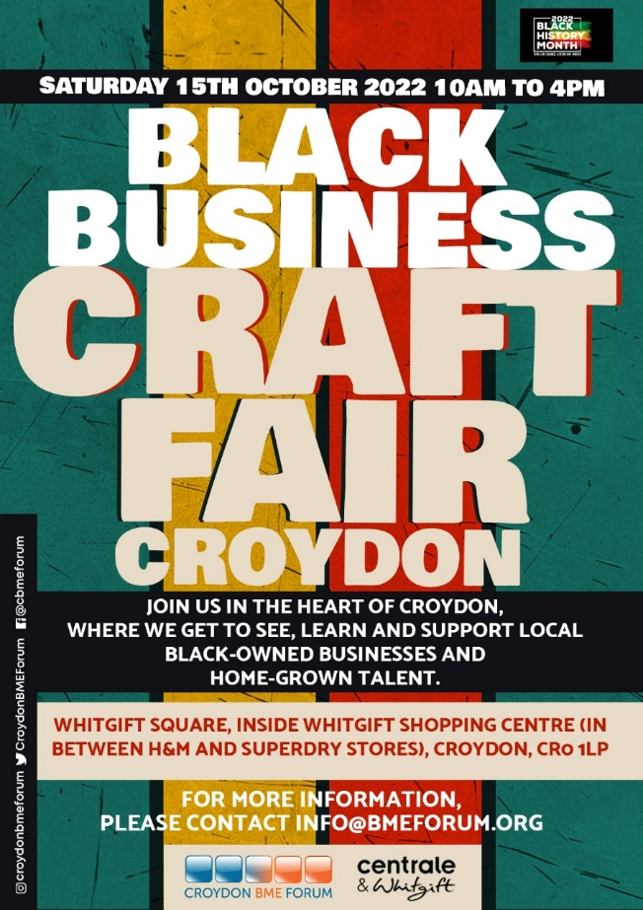

Black History Quiz night

Join us in Quiz night about Black History Month. This is an opportunity to learn about Black History. Join a team or come with your own team ready to engage.

Time: 7:00pm
Date: Wednesday 19th October 2022
Location: Oasis Restaurant, Croydon Health Services NHS trust
530 London Road Croydon CR7 7YE

‘What’s your first-time experience Going to the Caribbean

This session focuses on your first journey to the Caribbean from the UK. There is current interest to capture the stories of the migration experience in the UK. Let’s explore travelling over to where your parents left, for the first time.

What was your experience? How did the trip influence you? Would you go back? Are connections strong or lost across the Atlantic? Let’s talk about it and capture your thoughts for historical contributions.

Time: 6.30pm to 8.00pm
Date: Friday 21st October 2022
Location: Online
Age: Open to everyone

Black History Month Concert

The AOJUK Presents A Black History Month Concert, Lets celebrate together! Live musical performances, poetry recitals, raffle with greet prizes & more.

This is your opportunity to get your questions answered truthfully and hear about lived experiences.

Time: 7pm to 9.30pm
Date: Friday 14th October 2022
Location: St Oswald’s Church, Green Lane, Norbury, SW16 3SB
Tickets: Paid Event form Eventbrite – AOJUK Hotline 07368 399 801
******3rd Party Partnership event

Interview with Maisie Barrett - The Windrush Child - Our Stories

Description: Maisie will be telling her real-life story of being a Windrush Child and her experience in education, which is deemed her "educationally subnormal, and the impact on her life and her children. Maisie appeared in the BBC documentary Subnormal: A British Scandal.
Location: Live Event
Date: Tuesday 18th October 2022
Time: 7.00 PM

Money on My Mind - Launch Event

This is a launch event and the first of the four events in the series. This is an opportunity to find out how to best support yourself in a financial crisis while equipping your mental health. Come and see experts in Finance, Pension, and benefit entitlements.
Date: 19th October 2022
Time: 6.30pm to 8.00pm
Location: London South Bank, Croydon
Price: Free

The Psyche of a Black man

The second 2nd Psyche of a Black man in celebration of Black History Month. We are looking at the views of Black men in regards to Mental Health, racial discrimination and the next steps.

Time: 6.30pm to 8.00pm
Date: Monday 24th October 2022
Location: Front Room, Croydon

How to manage your studies and well-being’

Let’s explore engaging in education. Are you returning to studying?
How do you manage the coursework? How do you manage your mental health and well-being whilst studying?

Let’s talk about it and capture your thoughts for mutual support and our wellbeing.

Time: 6.30pm to 8.00pm
Date: Thursday 27th October
Location: Online

